**Fact sheets about new framework agreement for the supply of glassware to the laboratories.**

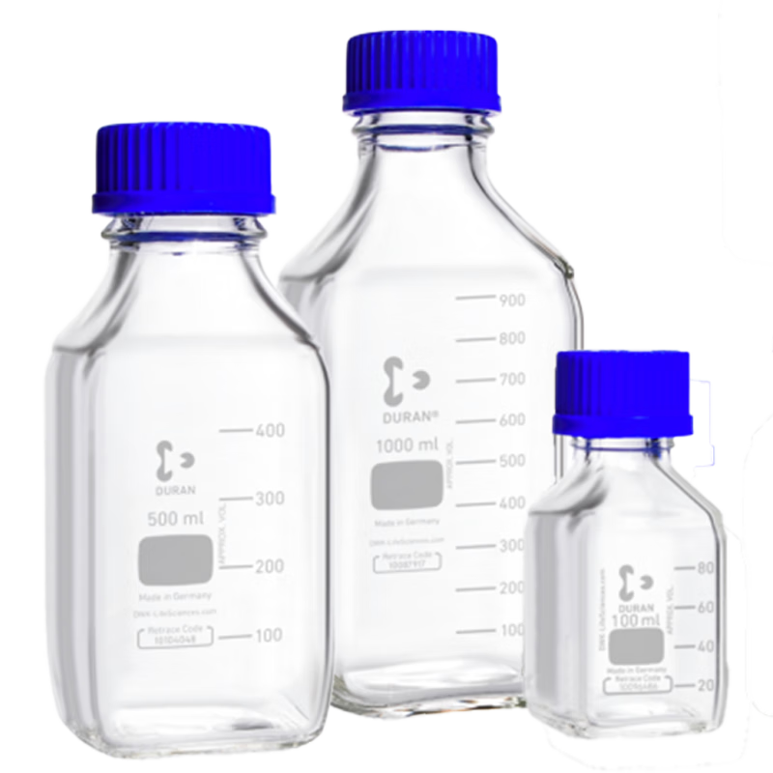

**Brief about the agreement**

Aalborg University, Aarhus University, University of Southern Denmark, Technical University of Denmark, University of Southern Denmark, and University of Copenhagen have jointly conducted a tender for the supply of glassware to the laboratories.

**Duration of the agreement**

The framework agreement is valid from 01-04-2025 and runs for 4 years.

**How to use the agreement**

The framework agreement is made with 3 suppliers. All purchases under the framework agreement will be made through direct allocation to the supplier that most cost-effectively meets the functional research needs ("needs model"). The functional research needs are based on a research assessment of which product best meets the customer's needs in connection with the specific purchase.

**Supplier information**

* VWR International A/S Cvr-nr.: 27335659 Tobaksvejen 21 2860 Søborg
* Th. Geyer Scandinavia ApS Cvr-nr.: 31333121 Borupvang 2B 2750 Ballerup
* Hounisen Laboratory Equipment A/S Cvr: nr. 25 57 34 20 Niels Bohrs Vej 49 8660 Skanderborg

**Order confirmation**

The supplier has 2 working days to send an order confirmation to the customer. The order confirmation must state the expected delivery time, correct item numbers, quantities, and prices, as well as any other deviations from the purchase order.

**Delivery terms**

The supplier must deliver the products to the specified address within 3 working days from the order, unless the parties agree otherwise. The above delivery deadline assumes that the products are ordered before 10:00 on a working day. If the products are ordered later, the delivery deadline is postponed by an additional 1 working day. For example, if the customer orders before 10:00 on a Thursday, and nothing else is agreed, delivery must take place no later than Tuesday of the following week. A specific delivery date that deviates from the generally set delivery deadlines can be set by written agreement.

**Fees**

For purchases with a value of less than DKK 500, the supplier may impose a minimum order fee of DKK 150.

**Returns**

AAU is entitled to return goods included in the delivery, provided the returned goods are in the same condition as at delivery. This means that the goods must be in unopened packaging and otherwise unused, in perfect condition, resalable, and not specially adapted to AAU. AAU's notice of return of goods must be given to the supplier no later than 14 days after delivery. The return goods must be returned to the address(es) in Denmark provided by the supplier. AAU is obliged to ensure that all deliveries of return goods are made in proper packaging.

Upon AAU's notice of return, the supplier may refuse returns of orders under DKK 500. For returns, the supplier may impose a return fee of 10% of the order price, but at least DKK 500. The supplier is not entitled to any other compensation in connection with the return. Upon return, the supplier must send a credit note to the customer as soon as possible. If the return is due to an error on the supplier's part, the return is made at the supplier's expense and risk. In this case, the supplier is not entitled to a return fee or other compensation in connection with the return. In this case, AAU has the burden of proof.

**Ordering**

Ordering should preferably be done through Aalborg University's purchasing system.

**Campaigns and market prices**

If the supplier conducts a campaign or other offer on a product covered by the framework agreement, where the price is lower than the current price on the framework agreement, the supplier must offer this campaign price to the customer.

If AAU can reasonably demonstrate that the market price is lower than the agreed price during the contract period, the supplier is obliged to adjust the prices for the individual goods to match the current market price. When determining the market price, the nature and scope of the goods as well as the risk and duration of the framework agreement must be taken into account. AAU's price must never be higher than the supplier's list prices for the product.

**Backorders**

The supplier must notify AAU when sending the order confirmation if there are ordered products that are on backorder or are special order items. The supplier must indicate an expected delivery time for the products in this notification. If the product has an expected delivery time of more than 10 working days from AAU's order, the supplier must offer AAU one of the following options: Receive a replacement item if the supplier can offer a product with equivalent quality and functionality. Cancellation of the ordered product. AAU is not obliged to accept replacement items.

**Ongoing follow-up on the agreement**

There will be ongoing follow-up on the agreement.